Nanjing University
limited
A dissertation for bachelor’s degree
of engineering


The Design and Implementation of Event-flow model of GUI-based Applications for testing

Author’s Name： Hou Xiaokun
Specialty： Software Engineering
Supervisor： Chen Zhenyu
Finished time: May 28th，2012

Abstract
Graphical user interfaces (GUIs) are playing an important role in today’s software and their correct execution is required to ensure the correctness of the overall software. A popular technique to detect defects in GUIs is to test them by executing test cases and checking the execution results. Test cases may either be created manually or generated automatically from a model of the GUI. While manual testing is unacceptably slow for many applications, and the cost of creating a GUI model is very high.
Here I will implement a newly proposed model called GUI forest and the event-flow graphs. And they can be generated directly from the executable GUI with reverse engineer method. [1][2]The tool can capture the structure of the software’s GUI through traversing the AUT by opening all its windows and extracting all their widgets (GUI objects), properties, and values. Then with the GUI structure, it will create an event-flow graph. In this article, I will present the core algorithm and the model data structure. Also I will describe the implementation of the tool based on Java-GUI.

Keywords：Java, EFG, GUI, Test Automation, JAXB
Contents
Abstract I
Chapter I Introduction 1
1.1 Background 1
1.2 Automation test development status and trends 1
1.3 My Work 2
1.4 Structure of the Article 3
Chapter II Technology Overview 4
2.1 Test Automation 4
2.2 XML 4
2.3 JAXB 4
2.4 MVC 5
Chapter III Requirement Analysis and High Level Design 6
3.1 Basic Knowledge 6
3.1.1 GUI 6
3.1.2 GUI Forest 6
3.1.3 Flow of Events 7
3.2 Requirement Analysis 8
3.2.1 GUI Capture 9
3.2.2 EFG Construction 10
3.3 High Level Design 11
Chapter IV Detail Design and Implementation 13
4.1 Detail Design of GUI Capture Subsystem 13
4.1.2 Core Algorithm 13
4.2 Implementation of GUI Capture Subsystem 14
4.2.1 GUI Forest 14
4.2.2 Detail 16
4.3 Detail Design of EFG Construction Subsystem 16
4.3.1 Core Algorithm 16
4.4 Implementation of EFG Construction Subsystem 17
4.4.1 EFG 17
4.4.2 Detail 19
Chapter V Conclusions and Future Work 20
REFERENCES 21

Chapter I Introduction

Background
The graphical user interfaces as a kind of good interactive way have been applied widely in common applications and software industries. The user experience is being taken seriously by more and more people and GUI code takes as high as 60% of the whole code. UI testing decides whether user experience is good or not and the quality of software directly.
GUI testing has been widely used in software industry. The current UI testing requires a lot of artificial participation, including writing test cases, running test case, and the testing result analysis, etc. The tools used are mostly typical record \ replay tools. It requires users manually to record operation and then save as test cases script, at last playback and compare with baseline. But what matters is that testing scripts are generated manually, and also there exists scripts maintenance problems.
There has been some research which is trying to build a suitable model to automatically generate test cases. For example, goal-directed search for GUI test case generation, function composition for automated test-oracle creation , metrics from graph theory to define test coverage criteria for GUIs, graph-traversal to obtain smoke test cases for GUIs that are used to stabilize daily software builds, and graph matching algorithms to repair previously unusable GUI test cases for regression testing, etc. But these models have limitations, narrow focus or the generation cost is too high.
Here we will adopt the event-flow graph model to realize the test cases generation automatically. [1][2]

1.2 Automation test development status and trends
There are two general approaches to test automation. One is code-driven testing and the other is graphic user interface testing. Here we will only talk about the GUI testing (or UI testing).
Below are some popular GUI testing tools in the industry:
Rational Robot is the industry's top function testing tool. With it the tester can do a successful test before learning advanced testing technology. It is integrated in testers’ desktop IBM Rational Test Manager. In it testers can do plan, organization, implementation, management and report all Test activities, including manual Test report. This double function of testing and management is the ideal start of test automation.
Win Runner is a kind of an enterprise-level functional test tool for inspecting whether the application is running as expected. Through the automatic capture, detection, and repeating the operation of the user interaction, Win Runner can identify weaknesses and ensure that no failures in the first release when cross multiple applications or several business processes of database, and maintain long-term reliable operation.
QuickTest Professional is a function test automation tool, mainly applied in regression testing. QuickTest focuses on the GUI application, including the traditional Windows applications, and Web applications that become more and more popular. It can cover most technology of the software development, simple and efficient, and have the test cases reusable characteristics. Its functions includes create test, insert the checkpoint, inspect data, enhancement test, test execution, results analysis and test maintenance, etc.
AdventNet QEngine is a widely used and platform-independent software test tool, can be used for Web function test, Web performance test, Java application function test, SOAP test, Java API test, regression test and Java application performance test. It support HTML, JSP, ASP, .net, PHP, JavaScript/VBScript, XML, SOAP, WSDL, e-commerce, traditional client/server application test. This tool use Java development, so that be friendly to transplantation and provide multi-platform support.
SilkTest…
QARun…
Test Partner…
All the tools are using the typical record and playback mode and it require testers to manual record test scripts. This is the place where is to be improved. We will create a tool to generate the test cases automatically directly from the application under test.

1.3 My Work
This tool will generate test cases automatically. And I am responsible for realizing the AUT’s GUI capture function, getting the hierarchical structure of the GUI function, and the event-flow graph construction module as well.

1.4 Structure of the Article
This paper introduces relevant theoretical knowledge about the UI testing and GUI modeling, and it will emphatically describe the design and implementation of Event-flow model of GUI-based applications at last.
Chapter I: Overview and Introduction part, mainly explain the current automated test development and the significance of test cases automatically generated.
Chapter II: Technology overview part. Introduce automation test, as well as the technology involved in the development process.
Chapter III: Requirements analysis and high level system design part. It includes the functional and non-functional requirements and an outline design.
Chapter IV: Detail design part. Describe core algorithm and data structure of the whole project.
Chapter V: Summary of the project part. Talk about the shortcomings and deficiencies of the project, and pointed out the future direction of expansion and development of the project.

Chapter II Technology Overview

2.1 Test Automation
Test automation is the use of software to control the execution of tests, the comparison of actual outcomes to predicted outcomes, the setting up of test preconditions, and other test control and test reporting functions. Commonly, test automation involves automating a manual process already in place that uses a formalized testing process.
There are two general approaches to test automation:
Code-driven testing. The public (usually) interfaces to classes, modules or libraries are tested with a variety of input arguments to validate that the results that are returned are correct.
Graphical user interface testing. A testing framework generates user interface events such as keystrokes and mouse clicks, and observes the changes that result in the user interface, to validate that the observable behavior of the program is correct.

2.2 XML
Extensible Markup Language (XML) [4] is a markup language that defines a set of rules for encoding documents in a format that is both human-readable and machine-readable.

2.3 JAXB
Java Architecture for XML Binding (JAXB) [5] allows Java developers to map Java classes to XML representations. JAXB provides two main features: the ability to marshal Java objects into XML and the inverse, i.e. to unmarshal XML back into Java objects. In other words, JAXB allows storing and retrieving data in memory in any XML format, without the need to implement a specific set of XML loading and saving routines for the program's class structure. Figure 2.2 shows that.
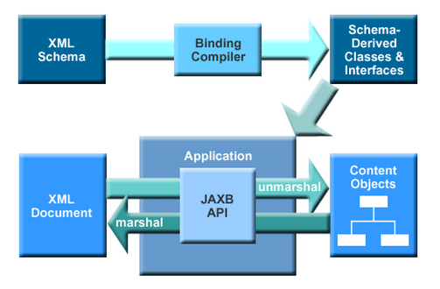
Figure 2.2 Processing Flow of JAXB

2.4 MVC

Controller

View
Module

Figure 2.3 MVC Structure

Chapter III Requirement Analysis and High Level Design

3.1 Basic Knowledge

3.1.1 GUI
GUIs are hierarchical. This hierarchy is reflected in the groups of windows, dialogs or hierarchical menus. The important characteristics of GUIs include their graphical orientation, event-driven input, hierarchical structure, the widgets they contain, and the properties (attributes) of those widgets. See the GUIs of Notepad in Figure 3.1.
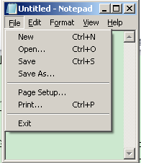
Figure3.1 GUIs of Notepad
3.1.2 GUI Forest
Based on the characteristics of the GUI, GUI forest is created. Intuitively, the GUI forest represents the structure of the GUI’s windows (as nodes of the forest), and the hierarchical relationship between windows (as edges). Each node encapsulates the state of a window that constitutes the window’s widgets, their properties, and values.
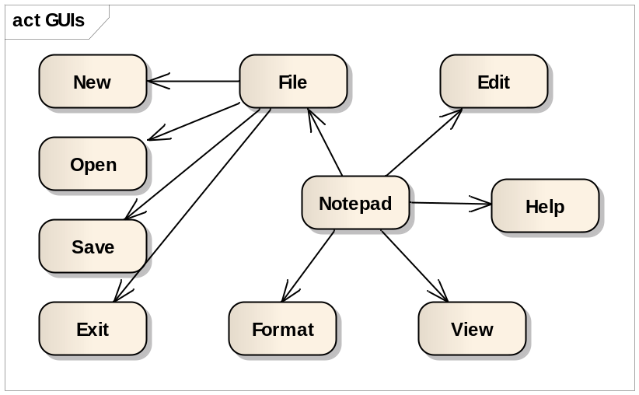
Figure3.2 GUI Forest of Notepad
Figure 3.2 shows the GUI forest (in this case a single tree) for Notepad. Note that the window that is presented to the user when Notepad is launched is called “top-level” (in this case it is Notepad) and forms the root of the tree. All other windows are either invoked from top-level or from one of the child windows.

3.1.3 Flow of Events
The GUI forest in its raw form is not useful for test case generation. We collect additional information during capture the GUI hierarchy to develop new structures that model the GUI’s execution behavior that we call its flow of events. To create the events flow, what matters is to get the set of events can be reachable after an event. To do this, it needs to extract the event type during the GUI traversing process.
The first class of events, called restricted-focus events open modal windows. For example, Set Font is a restricted-focus event. The second class, called unrestricted-focus events open modeless windows. For example, Replace in Notepad is an unrestricted-focus event. Termination events close modal windows; common examples include OK and Cancel.
The GUI contains other types of events that do not open or close windows but make other GUI events available. These events, called menu-open events are used to open menus. They expand the set of GUI events available to the user. Menu-open events do not interact with the underlying software. Note that the only difference between menu-open events and unrestricted-focus events is that the latter open windows that must be explicitly terminated. For example, in Notepad, File and Edit are menu-open events.
Finally, System-interaction events interact with the underlying software to perform some action; common examples include the Copy event used for copying objects to the clipboard.
An example of an event-flow graph for the Notepad is shown in Figure 3.3. The nodes represent events in the component and the edges show the follows relationship. Find a path in the graph, for example, “Help->Edit->File->Open” is a test case in the Nodepad.
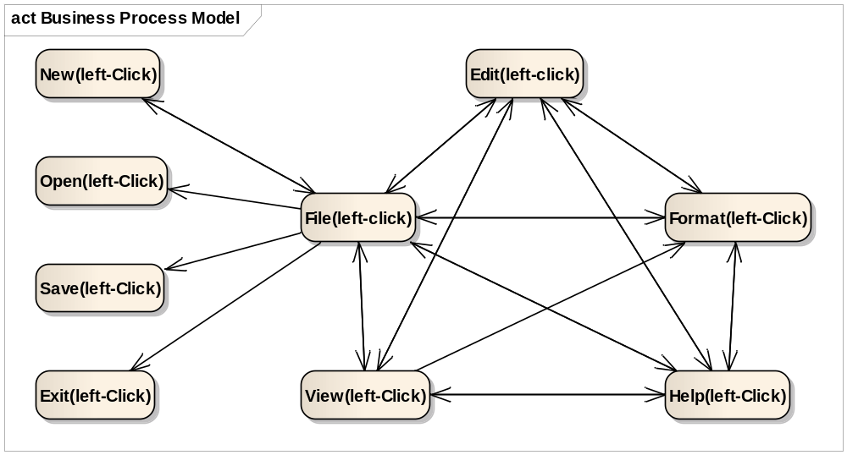
Figure3.3 EFG of Notepad

In the next chapter, we describe the algorithms of the GUI capture process and EFG generation process.

3.2 Requirement Analysis

3.2.1 GUI Capture
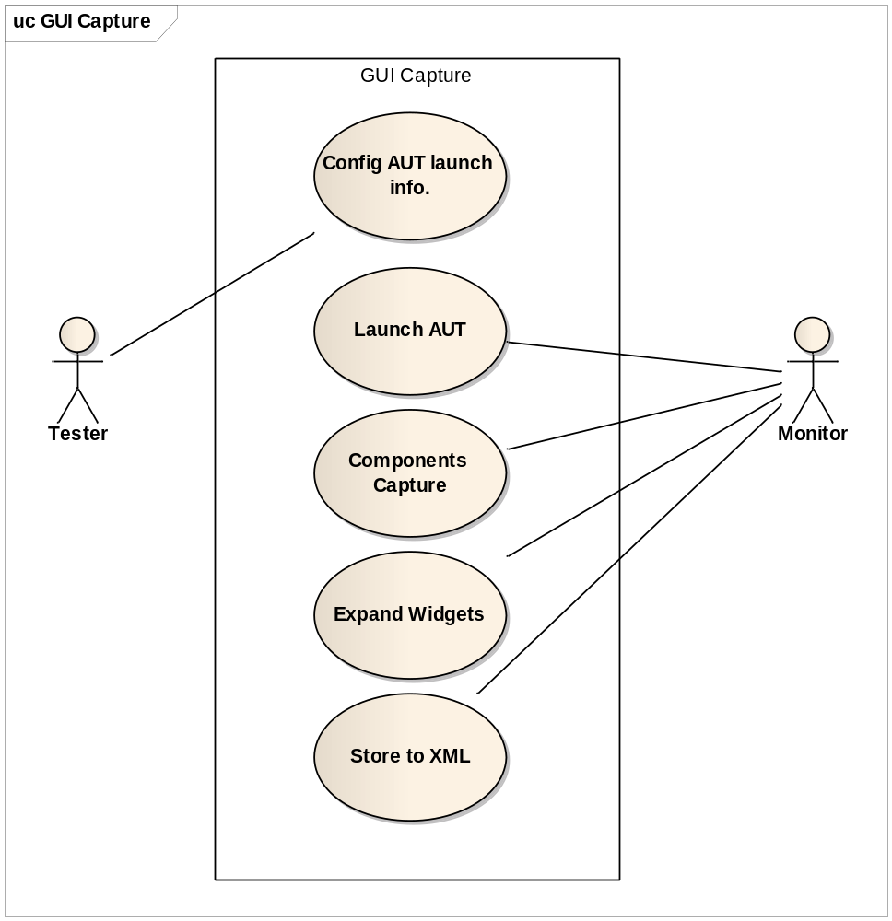
Figure 3.1 User Cases for GUI Capture

3.2.2 EFG Construction
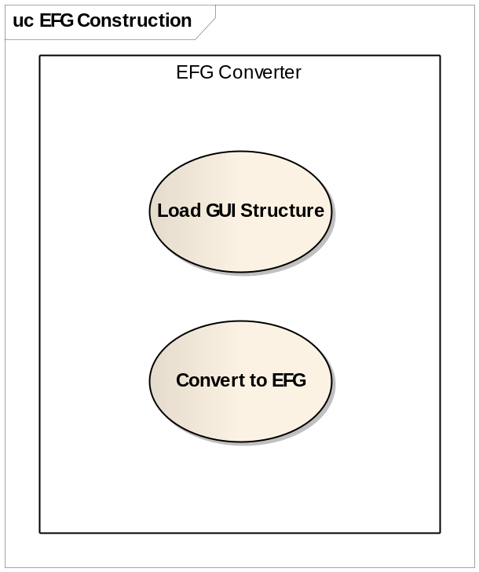
Figure 3.2 User Cases for EFG Construction

3.3 High Level Design
Two sub system, one is GUI Capture subsystem to traverse all the windows and store the GUI Structure in the XML. The other is the EFG Converter subsystem to convert the GUI Structure to the EFG model.

Figure 3.3 High Level Design

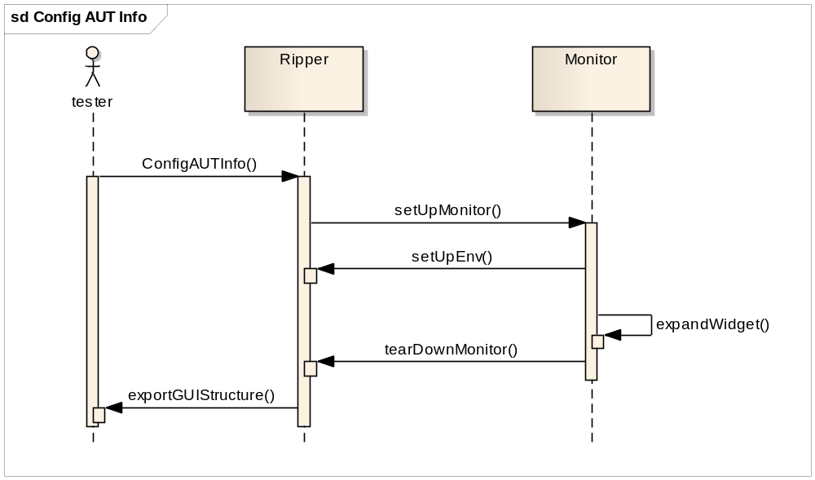
Figure 3.4 Sequence of GUI Capture

Chapter IV Detail Design and Implementation

4.1 Detail Design of GUI Capture Subsystem

4.1.2 Core Algorithm
As discussed earlier in Chapter 3, the GUI of an application is structured as a forest. We obtain this structure by performing a depth-first traversal of the hierarchical structure of the GUI. See the detail in Figure 4.1.
GUI/*GUI tree of application under test*/
PROCEDURE DFS-GUI(Application A) 1 T=access-top-level-windows(A) 2 GUI=T 3 /*T is set of top-level windows in the application*/
FORALL t∈ T DO 4
DFS-GUI-Recursive(t) 5

PROCEDURE DFS-GUI-Recursive(Window g) 6 W=get-widget-list-and-properties(g) 7
/*W is the set of all widgets in the window*/
E=identify-executable-widgets(W) 8
/*From W identify executable widgets*/
FORALL e ∈ E DO 9
Execute-widget(e) 10
/*Execute the widget e*/
C=get-invoked-gui-windows(e) 11
GUI=GUI ∪ g 12
FORALL c∈C DO 13
DFS-GUI-Recursive(c) 14
Figure 4.1 GUI Traversing and Extracting the GUI of an Application
The function DFS-GUI (line 1) takes an application as an input. The function access-top-level-windows (line 2) return the top-level windows of the application. Then Call the function DFS-GUI-Recursive (line4、5) for every top-level window. A GUI tree is constructed for each of the top-level window by invoking the procedure. At the termination of the algorithm, GUI contains the GUI forest of the application.
DFS-GUI-Recursive traverses a certain window and extracts its structure. The procedure performs a depth-first search for the GUI tree rooted at the GUI window g. In line 7 the call to get-widget-list-and-properties returns a list W of the constituent widgets in the GUI window g. The function identify-executable-widgets in line 6 searches the set W and returns a list of widgets which invokes other GUI windows. This is because not all of the widgets in W invoke other GUI windows.
A widget that invokes other GUI windows is executed by execute-widget in line 10. When executed, e may invoke one or more GUI windows. The function get-invoked-gui-windows in line 11 returns the list of GUI windows invoked by e. Note that each of the GUI windows c in the set C are child nodes of the node g in the GUI tree. The GUI tree GUI is updated in line 12. This is done by inserting each GUI Window c from C as a child node of the GUI window g. Lines 13–14performs a recursive search of the sub-tree rooted at each of the invoked GUI window c.
When the procedure DFS-GUI-Recursive returns to DFS-GUI, the tree rooted at the top-level window t is constructed. At the completion of the procedure DFS-GUI, the complete GUI forest of the application under test is available in GUI.
The algorithm described in Figure 4.1 is general and can be applied to any GUI defined in Chapter 3. Later, we will describe how the high-level functions used in the algorithm and implemented using Java API.

4.2 Implementation of GUI Capture Subsystem

4.2.1 GUI Forest
In Figure 4.2 it shows the data format of GUIStructure with XML schema. With JAXB, it’s convenient to transform the Java object to a formatted xml file.
<!-- GUIStructue root level -->
<xs:element name="GUIStructure">
<xs:complexType>
<xs:sequence>
<xs:element maxOccurs="unbounded" minOccurs="1" name="GUI" type="GUIType"/>
</xs:sequence>
</xs:complexType>
</xs:element>
<!-- Individual GUI representing a window -->
<xs:complexType name="GUIType">
<xs:sequence>
<xs:element maxOccurs="1" minOccurs="1" name="Window" type="ComponentType"/>
<xs:element maxOccurs="1" minOccurs="1" name="Container" type="ContainerType"/>
</xs:sequence>
</xs:complexType>
<!-- A GUI container containing one or more children component -->
<xs:complexType name="ContainerType">
<xs:complexContent>
<xs:extension base="ComponentType">
<xs:sequence>
<xs:element name="Contents" type="ContentsType"/>
</xs:sequence>
</xs:extension>
</xs:complexContent>
</xs:complexType>
<!-- A set of GUI components under a Container -->
<xs:complexType name="ContentsType">
<xs:sequence>
<xs:choice maxOccurs="unbounded" minOccurs="1">
<xs:element name="Widget" type="ComponentType"/>
<xs:element name="Container" type="ContainerType"/>
</xs:choice>
</xs:sequence>
</xs:complexType>
<!-- A GUI container containing one or more children -->
<xs:complexType name="ComponentType">
<xs:sequence>
<xs:element maxOccurs="1" minOccurs="1" name="Attributes" type="AttributesType"/>
<xs:element maxOccurs="1" minOccurs="0" name="Optional" type="AttributesType"/>
</xs:sequence>
</xs:complexType>
<!-- Attributes of a GUI window/component, containing a set of key-values pair GUI properties -->
<xs:complexType name="AttributesType">
<xs:sequence>
<xs:element maxOccurs="unbounded" minOccurs="1" name="Property" type="PropertyType"/>
</xs:sequence>
</xs:complexType>
<!-- Individual key-values pair GUI property -->
<xs:complexType name="PropertyType">
<xs:sequence>
<xs:element maxOccurs="1" minOccurs="1" name="Name" type="xs:string"/>
<xs:element maxOccurs="unbounded" minOccurs="1" name="Value" type="xs:string"/>
</xs:sequence>
</xs:complexType>
Figure 4.2 GUI Forest Data Structure
The root node is the GUIStructure, composed by many GUI elements, each GUI represents a window.
GUI node has two child nodes. The first element is Window, just only one, and describes the basic attributes of the Window. The second part is the Container, also can have only one, and describes the widgets in the window and their attributes.
Container node has two types of child nodes. One is Widget, describes the widgets in the window. The other is Container, describes sub-container in the container. And every widget has a set of key value properties. For example,
ID: widget id
Class：Widget type
Type：Event type
X、Y：Widget location
Title：Widget title
…

4.2.2 Detail
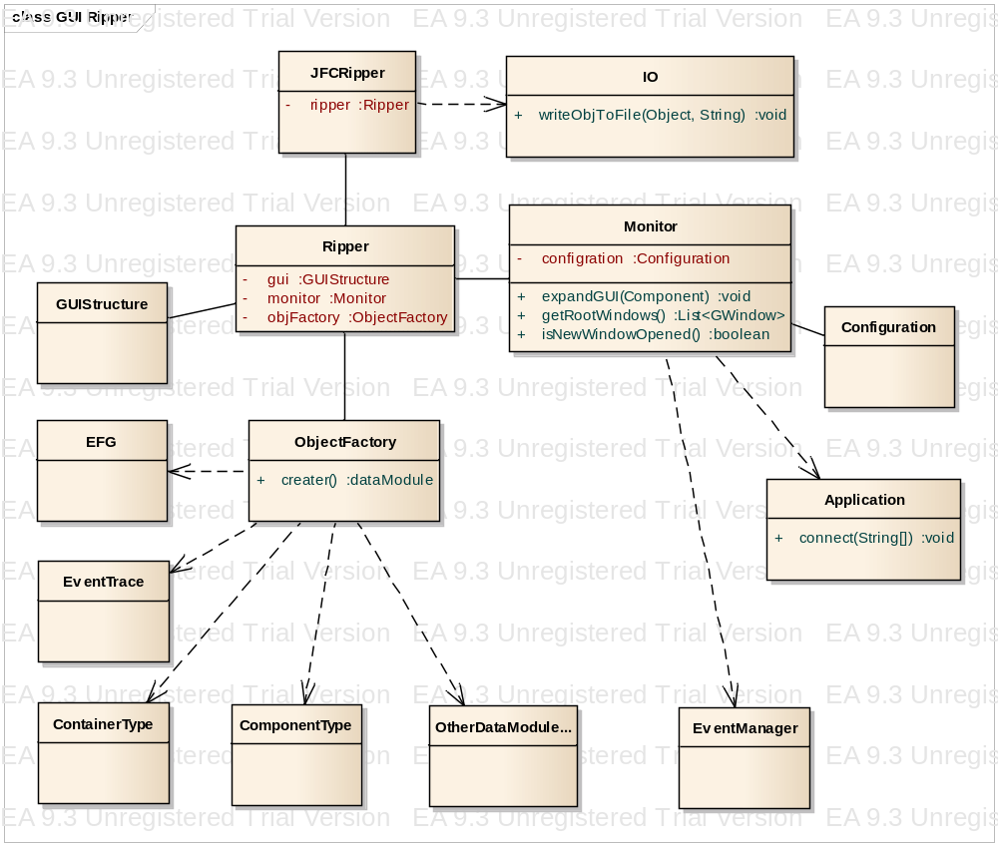
Figure 4.3 Class Diagram

4.3 Detail Design of EFG Construction Subsystem

4.3.1 Core Algorithm
The construction of the event-flow graphs and integration tree is based on the identification of modal dialogues and, hence, the identification of modal and modeless windows and their invokes relationships. A classification of GUI events is used to identify modal and modeless windows. Restricted-focus events open modal windows. Unrestricted-focus events open modeless windows. Termination events close modal windows. Menu-open events are used to open menus. System-interaction events are not used to manipulate the structure of the GUI; rather, they are used to interact with the underlying software to perform some action.
The classification of events is used by an algorithm to construct event-flow graphs for a GUI. The algorithm computes the set of follows for each event. These sets are then used to create the edges of the event-flow graph.
The set of follows (v) can be determined using the algorithm in Figure 1 for each vertex v. The recursive algorithm contains a switch structure that assigns follows (v) according to the type of each event. If the type of the event v is a menu-open event ( line 2)and v ∈ B (events that are available when a modal dialogue is invoked), then the user may either perform v again, its sub-menu choices, or any event in B ( line 4). However, if v not∈B, then the user may either perform all sub-menu choices of v , v itself, or all events in follows( parent ( v )) (line 6); Parent (v ) is defined as any event that makes v available. If v is a system-interaction event, then after performing v, the GUI reverts back to the events in B (line 8). If v is a termination event, i.e. an event that terminates a modal dialogue, then follows ( v ) consists of all of the top-level events of the invoking modal dialogue ( line 10). If the event type of v is an unrestricted-focus event, then the available events are all top-level events of the invoked modal dialogue available as well as all events of the invoking modal dialogue (line 12). Lastly, if v is a restricted-focus event, then only the events of the invoked modal dialogue are available.
ALGORITHM： GetFollows(v: Vertex or Event){ 1
IF EventType(v)=menu-open 2
IF v∈B of newly invoked modal dialogue 3
return (MenuChoices(v)∪{v}∪B) 4
ELSE 5
return MenuChoice(v)∪{v}∪follows(parent(v))) 6
IF EventType(v)=system-interaction 7
return(B of current window) 8
IF EventType(v)=termination 9
return(B of Invoking modal dialogue) 10
IF EventType(v)=unrestricted-focus 11
return(B∪B of Invoked modal dialogue) 12
IF EventType(v)=restricted-focus 13
return(B of Invoked modal dialogue) 14

Figure 4.4 Computing follows(v)for a vertex v

4.4 Implementation of EFG Construction Subsystem

4.4.1 EFG
<!-- EFG root level -->
<xs:element name="EFG">
<xs:complexType>
<xs:sequence>
<!-- Event information -->
<xs:element maxOccurs="1" minOccurs="1" name="Events" type="EventsType"/>
<!-- Edge Adjacency matrix -->
<xs:element maxOccurs="1" minOccurs="1" name="EventGraph" type="EventGraphType"/>
</xs:sequence>
</xs:complexType>
</xs:element>
<!-- Set of events -->
<xs:complexType name="EventsType">
<xs:sequence>
<xs:element maxOccurs="unbounded" minOccurs="1" name="Event" type="EventType"/>
</xs:sequence>
</xs:complexType>
<!-- Individual event -->
<xs:complexType name="EventType">
<xs:sequence>
<!-- Event Identifier in the graph -->
<xs:element maxOccurs="1" minOccurs="1" name="EventId" type="xs:string"/>
<!-- The corresponding widget ID in the GUI file -->
<xs:element maxOccurs="1" minOccurs="1" name="WidgetId" type="xs:string"/>
<!-- Event type: there are 5 type of events considered in the EFG -->
<xs:element maxOccurs="1" minOccurs="1" name="Type" type="xs:string"/>
<!-- Initial event true if the event is available right after the application starts -->
<xs:element maxOccurs="1" minOccurs="1" name="Initial" type="xs:boolean"/>
<!-- Actual action can be performed on the event like click, type text -->
<xs:element maxOccurs="1" minOccurs="1" name="Action" type="xs:string"/>
<!-- Optional: Event name -->
<xs:element maxOccurs="1" minOccurs="1" name="Name" type="xs:string"/>
<!-- Optional: Event listener -->
<xs:element maxOccurs="unbounded" minOccurs="0" name="Listeners" type="xs:string"/>
<!-- Optional: fields for events -->
<xs:element maxOccurs="1" minOccurs="0" name="Optional" type="AttributesType"/>
</xs:sequence>
</xs:complexType>
<!-- EFG edge Adjacency matrix -->
<xs:complexType name="EventGraphType">
<xs:sequence>
<xs:element maxOccurs="unbounded" minOccurs="1" name="Row" type="RowType"/>
</xs:sequence>
</xs:complexType>
<xs:complexType name="RowType">
<xs:sequence>
<xs:element maxOccurs="unbounded" minOccurs="1" name="E" type="BooleanType"/>
</xs:sequence>
</xs:complexType>
<!--
Value of row r_th and column c_th in the EFG edge's Adjacency matrix
- value = 0: no edges
- value > 0: there is an edge from event r_th to c_th in the graph (referred by their
indices in the Event list)
+ 1: Normal edge
+ 2: Reaching edges: the edges that that open a new window or reveal events hidden under the GUI's hierarchical structure (e.g, File -> New).
Those edge are given a higher priority when finding path to reach an event.
-->
<xs:simpleType name="BooleanType">
<xs:restriction base="xs:int">
<xs:enumeration value="0"/>
<xs:enumeration value="1"/>
<xs:enumeration value="2"/>
</xs:restriction>
</xs:simpleType>
Figure 4.5 EFG Structure

4.4.2 Detail
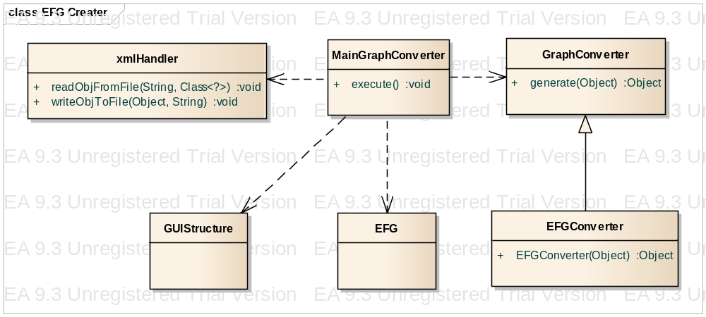
Figure 4.6 Class Diagram

Chapter V Conclusions and Future Work
Automated testing of software that has a graphical user interface (GUI) has become extremely important as GUIs become increasingly complex and popular. A key step to automatically test GUI software is test case generation from a model of the software. Our experience with GUI testing has shown that such models are very expensive to create manually and software specifications are rarely available in a form to derive these models automatically. We presented a new technique, called GUI ripping to obtain models of the GUI’s structure and execution behavior automatically. We represented the GUI’s structure as a GUI forest and its execution behavior as event-flow graphs. We described the GUI ripping process, which is applied to the executing software. The process opens all the software’s windows automatically and extracts all their widgets, properties, and values. The execution model of the GUI was obtained by using a classification of the GUI’s events. Once the extracted information is verified by a test designer, it is used to automatically generate test cases. We empirically showed that our approach requires very little human intervention. We have implemented our algorithms in a tool called a “GUI Ripper”.
In the future, we will extend our implementation to handle more MS Windows GUIs, UNIX, and web applications.
We will also use the GUI ripper for performing usability analysis of GUIs. It will also be extended for measuring specification conformance of GUIs.

REFERENCES
[1] Atif Memon, GUI Ripping: Reverse Engineering of Graphical User Interfaces for Testing
[2] Atif M. Memon,An event-ﬂow model of GUI-based applications for testing
[3] Java, http://zh.wikipedia.org/wiki/Java
[4] XML, http://zh.wikipedia.org/wiki/XML
[5]JAXB, http://www.oracle.com/technetwork/articles/javase/index-140168.html#author
[6] MVC, Eric Freeman, Elisabeth Freeman, Kathy Sierra, Bert Bates. Head First Design Pattern. O’Reilly. 2007

More information about Rational Robot refers to: http://www-306.ibm.com/software/rational/
More information about Win Runner refers to: http://www-306.ibm.com/software/rational/
More information about QuickTest Professional refers to: http://www-306.ibm.com/software/rational/
More information about AdventNet QEngine refers to: http://www.adventnet.com
More information about AdventNet QEngine refers to: http://www.adventnet.com
More information about AdventNet QEngine refers to: http://www.adventnet.com
More information about AdventNet QEngine refers to: http://www.adventnet.com

